**On Atomic Structure**

**Ghanshyam Jadhav**

**Dept. of Physics, Shri Chhatrapati Shivaji College, Omerga-413606, India**

**Email: ghjadhav@uniphysics.org.in**

**Web:** [**www.uniphysics.org**](http://www.uniphysics.org)

**Introduction:**

Up to the 19th century, atoms were believed to be the smallest units of matter that are indivisible. The first breakthrough came in the late 1800s when English physicist Joseph John Thomson discovered that the atom wasn’t as indivisible as previously claimed. He carried out experiments using cathode rays produced in a discharge tube, and found that the rays were attracted by positively charged metal plates but repelled by negatively charged ones. From this he deduced the rays must be negatively charged. Thus, in 1897, he discovered the electron. He believed atoms could be divided. Because the electron carried a negative charge, he proposed a plum pudding model of the atom in 1904, in which electrons were embedded in a mass of positive charge to yield an electrically neutral atom.

Ernest Rutherford was a physicist from New Zealand who studied at Cambridge University under Thomson. It was his later work at the University of Manchester which would provide further insights into the insides of an atom. He devised an experiment to probe atomic structure which involved firing positively charged alpha particles at a thin sheet of gold foil and found that the positive charge of an atom and most of its mass were at the center, or nucleus of an atom. Therefore, he proposed a planetary model in which electrons orbited a small, positive-charged nucleus. Rutherford was on the right track, but his model couldn't explain the emission and absorption spectra of atoms, nor why the electrons didn't crash into the nucleus. In 1913, Niels Bohr proposed the Bohr model, which states that electrons only orbit the nucleus at specific distances from the nucleus. According to his model, electrons couldn't spiral into the nucleus but could make quantum leaps between energy levels. He postulated the existence of energy levels or shells of electrons. Electrons could only be found in these specific energy levels; in other words, their energy was quantized, and couldn’t take just any value. Electrons could move between these energy levels referred as ‘stationary states’ but had to do so by either absorbing or emitting energy.

Bohr’s model didn’t solve all the atomic model problems. It worked well for hydrogen atoms, but couldn’t explain observations of heavier elements. It also violates the Heisenberg Uncertainty Principle. Thus the Bohr’s model was still required refining. At this point, many scientists were investigating and trying to develop the quantum model of the atom.

While solving the crisis of photoelectric effect, Einstein had published his paper in 1905 providing revolutionary explanation on the photoelectric effect. It was based on his “light quanta” hypothesis. He proposed that the light behaves as a stream of independent, localized units of energy called ‘light quanta’ each light quanta has an energy *hν* where *ν* is the frequency of the light wave and *h* is the plank’s constant. As light waves can behave as light quanta like particles, then a particle should also behave as a wave. This proposition was first put by L de Broglies proposing duel nature of matter waves. That concept was further used by E Schrödinger. In 1926 E Schrödinger proposed that, rather than the electrons moving in fixed orbits or shells, the electrons behave as waves. Schrödinger solved a series of mathematical equations to come up with a model for the distributions of electrons in an atom. His model shows the nucleus surrounding by clouds of electron density. These clouds are probability of finding the electrons though we don’t know exactly where they are. These regions of space are referred to as electron orbitals.

In 1932, the English physicist James Chadwick discovered the existence of the neutron, completing our picture of the subatomic particles that make up an atom. The story doesn’t end there either; physicists have since discovered that the protons and neutrons that make up the nucleus are themselves divisible into particles called quarks.

Until the end of 20th century, there was no any definite idea or understanding of atom. Development of the atomic models made clear the fact that the nucleus is at the central place of the atom and electrons are just distributed around the nucleus. But how the electrons can maintain their safe distance from the nucleus is still part of debate. Schrödinger proposed that the electrons behave as waves rather than moving in fixed orbits or shells. He developed mathematical model for distribution of electrons in atom showing the nucleus is surrounded by clouds of electron density. These clouds give the probability of finding the electrons and are referred to as electron orbitals. But the photoelectric effect explanation proposes that in electromagnetic waves, magnetic force increases with increase in frequency indicating that the magnetic force in light wave might be responsible to produce the photoelectric effect. The discussion further suggests that the asymmetric electric force produced by electric field in the light wave is responsible to produce an apparent force which can be the true nature of magnetic force. If the magnetic force or the apparent force in light wave is found to be responsible to produce the photoelectric effect then the duel nature of matter is to reconsider once again. It may be suggesting that the electrons are not behaving as waves. On this advent, how the electrons in the atoms are being distributed around the nucleus becomes unanswered. Aim of this presentation is to make investigation in this regard.

**Spin of electrons:**

Electron spin refers to a quantum property of the electrons and we believe that it is a fundamental property just like charge and rest mass. Therefore, the spin should be always associated with the electron though it is in atom or free from atom. Unfortunately we sometimes ignore on experiments, that are being performed in general physics laboratories, giving valuable scientific information. Such one experiment is e/m by Thomson method giving valuable information about spin of electron is intrinsic or not. A particular deflection of electron beam, in this experiment, due to the magnetic field between two poles of bar magnets is shown in figure 1. Before application of the magnetic field, the electron beam was sharp. After application of the magnetic field, the electron beam is however deflected in upward direction but is again sharp producing a single spot on the screen. However, if electrons possess intrinsic spin, a line should be produced on the screen which is not found indicating that the electrons do not possess intrinsic spin which could be understood from the following explanation using asymmetric electric field and force.

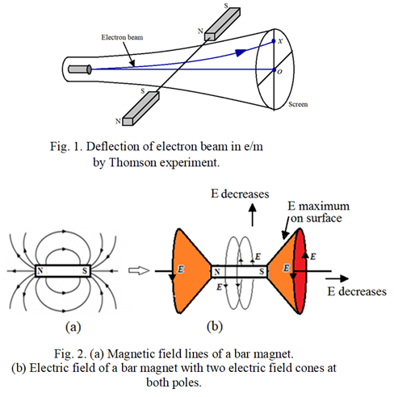

On absence of magnetic monopoles in the universe, the true nature of magnetic field and magnetic force is investigated and proposed that a straight long current would produce a parallel electric field in opposite direction of the current which produces asymmetric electric force on a charged particle placed in it consequently the charged particle follows a curved path. That motion of the charged particle along a curved path can be visualize under the action of two forces, one the effective electric force because of the electric field and the other is the apparent force which is always perpendicular to the velocity of the charged particle and whose magnitude depends on the asymmetric nature of the electric force. It suggests that the apparent force should be the true nature of magnetic force. Using this proposition, the photoelectric effect was analyzed. It suggested that the magnetic force should increase with increase in frequency of electromagnetic wave which could be responsible to produce the photoelectric effect. However, experimental verification of this proposition is to be confirmed yet. In sequence of this discussion, as a straight long current produces parallel electric field, a bar magnet should produce circular electric field as illustrated in figure 2 having two electric field cones at both poles of the magnet. The electric field strength is maximum on the surface of the cone and it increases away from center. The electric field between the two poles of magnets in figure 1 is represented in figure 3 which increases away from the center. Deflection of electron beam using this circular electric field is explained below.

Consider one electron in the electron beam of cathode ray tube (CRT) moving towards the screen with particular velocity through the electric field as represented in figure 3. This electric field applies asymmetric electric force on the electron which should be explained in terms of field-field interaction. The electric force on the electron’s field is in opposite direction of the circular electric field. At position 1, the electron’s electric field can be divided into two hemispheres, back and front. Force on the back field of the electron is more than the force on the front field because of which the electron turns in upward direction as it has forward velocity. At position 2, the electron’s field is to be again divide into lower and upper hemispheres. The upper field of the electron experiences greater force than its lower field because of which the electron turns in upward direction again. At position 3, the electron’s field can be again divided into two hemispheres, front and back. The front field of the electron experiences more force than its back field because of which its moves again in upward direction. As all the electrons in the beam of CRT possess same velocity, they will travel along same path producing a sharp spot on the screen.

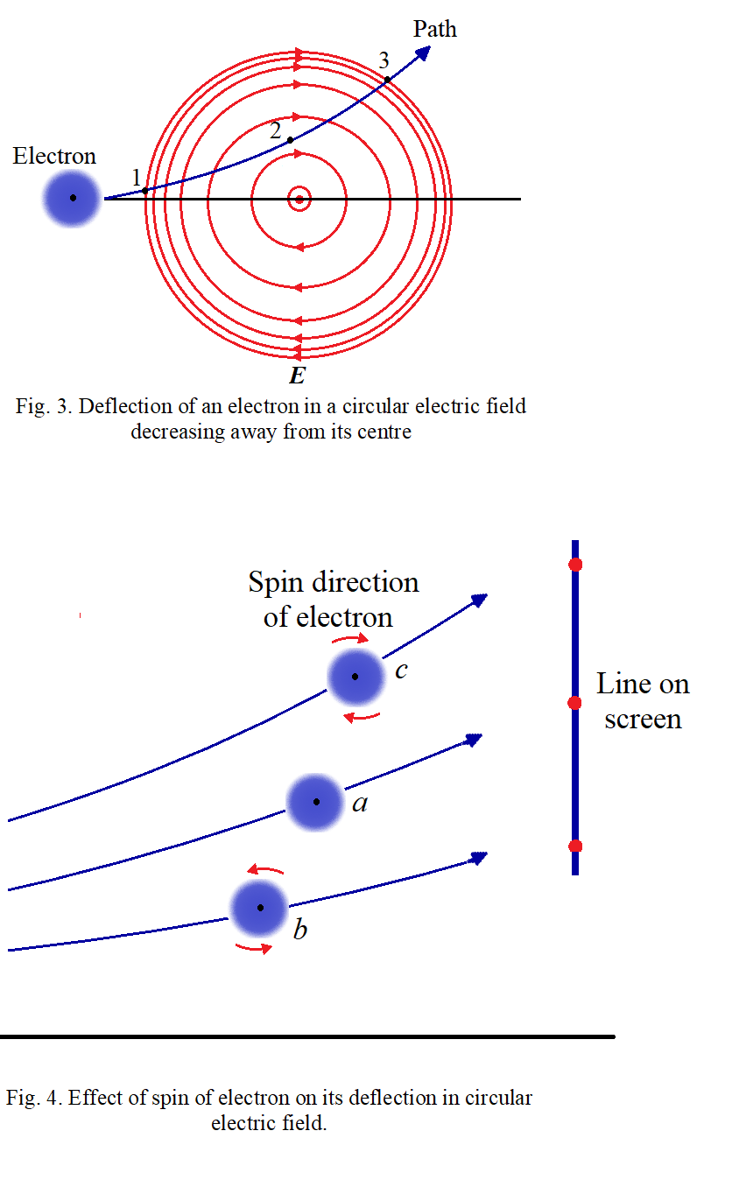

In this explanation, the intrinsic spin of the electron is not taken into account and is represented by the curve ‘*a*’ in figure 4. If the electron possesses intrinsic spin then it can affect the deflection of the electron. Suppose it has clockwise spin as indicated in figure 4(b), then the strongest force on the electron’s field is in opposite direction of the spin motion because of which the electron will be deflected more in upward direction or towards the strong field region as indicated by curve ‘*c*’. If the electron spin is in anticlockwise direction then the strongest force on the electron’s field is in the direction of the spin because of which the electron will be deflected less as shown by curve ‘*b*’. The electrons in the electron beam may have randomly oriented spin because of which a line should be produced on the screen, as indicated in figure 4, which is not found experimentally indicating that the electrons in the electron beam do not possess any spin. Consequently, when electrons become free from their atoms they lose their spin implying spin is not intrinsic property of electrons. Therefore, the electrons may be acquiring spin through the need of arranging them in atoms. Thus, in distribution of the electrons in atoms, the electron’s spin should play important role. To understand it, the levitation of superconductor is to be understand properly as explained below.

**Levitation of superconductor:**

The levitation of superconductor in terms of asymmetric electric force applied by the circular electric field of bar magnet is illustrated in figure 5. The circular electric field of bar magnet, which decreases away from the magnet, produced electric current in the superconductor in the direction of the field. Therefore, the electric field of the magnet tries to push the electrons in the conductor, contributing the current, into the weak field region or away from the magnet. In similar way, the electric current in the superconductor produces circular electric field in opposite direction of the current which tries to increase the current in the magnet produced by unpaired electrons because of which the unpaired electrons in the magnet get pushed away from the superconductor. In this way a repulsion between magnet and superconductor is found which is considered as superconductor acts as a diamagnetic substance. If we place a superconductor on a magnet as illustrated in figure 5, then it will get levitated because of the repulsion between them. By increasing the distance between them, the repulsive force between them decreases as the strength of the electric field of the magnet linked to the superconductor decreases which causes to decrease the current produced in the superconductor. Similarly by decreasing the distance between the magnet and superconductor, the repulsive force between them increases as the strength of the electric field of the magnet linked to the superconductor increases which causes to increase the current produced in the superconductor. The gravitational force on the superconductor is constant therefore, the distance between the superconductor and magnet will get adjusted until the repulsive force between them and the gravitational force on the superconductor get balanced resulting into levitation of the superconductor. Thus the current produced in the superconductor is reached to the value such that the repulsive force and the gravitational force are balanced. Such things should also happen while rearranging the electrons in atoms.

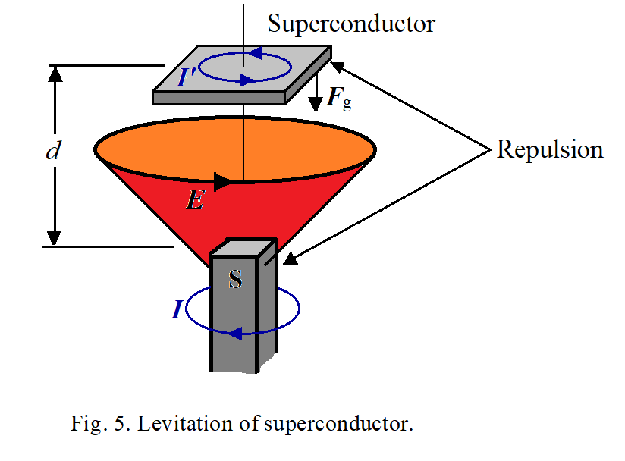

**Atomic model of helium:**

Helium atom consists only two electrons, therefore it will be a simplest atomic mode to understand the role of spin of electrons. Generally electron has spherical symmetric electric field around itself. When such two electrons are brought close to each other, they will apply maximum force on each other to repel. Due to spin motion of an electron its electric field gets modified such that it has non-zero circular component about the axis of the spin. Increase in spin velocity should cause to increase in circular component of the electric field. Therefore, when two electrons which are in spin motion about same axis are brought close to each other, the circular electric field component of one electron will produce force on other electron in such a way that it will get spin motion in opposite direction of the first. This causes to reduce the net repulsion between them. Increase in spin velocity should cause further decrees in repulsion. In helium atom, there are two electrons. They can be arranged on opposite side of the nucleus such that the nucleus attracts them and the electrons themselves to repel each other. To reduce the repulsion between them, the electrons will be triggered to have spin motion in opposite direction of each other. Further the spin velocity of the electrons will be adjusted such that the repulsion between them and the attraction between the nucleus and the electrons will be balanced. If the electrons are more close to each other, high spin velocity will be required to reduce the repulsion. If the electron spin is quantized means it can have only certain values then the distance of the electron from nucleus in atoms will also be quantized. Thus, the electrons, in atoms, have no need to revolve in orbits to maintain their particular distance from nucleus as stated by Bohr. Further they are not behaving as waves as proposed by de Broglie [12]. Using their spin motion, they can maintain a particular or safe distance from the nucleus in atoms. Thus, spin is not intrinsic property of electrons. A simple atomic model for helium atom is shown in figure 6.

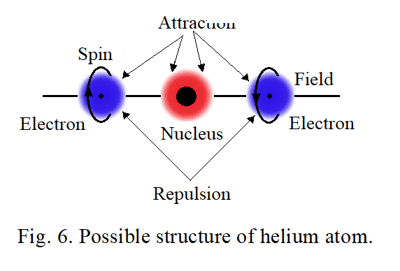

**On charged particles:**

It is difficult to understand why and how the charged particles are created and why they are applying fore on each other. What is need of the space, because of which the charged particles are behaving like thus, is very important to understand. For that it is important to look in what wav we think about the field, especially about electric field, around a charged particle. The field is spherical symmetric around charged particles and can get propagated in terms of waves in space. It implies that the electric field should be simply a pressure. To create a pressure and propagation of that pressure requires an elastic medium. It means the space should be filled with that medium which was already considered as an aether but could not be proved. What we imagine about aether decides how to prove it. At present we keep the subject aside. Propagation of electric field in terms waves indicates that the field is simply a pressure. Electron has electric field and is spherical symmetric implies that the pressure should be either inward or outward. If we consider the pressure is outward or say negative electric field, then there should be other particles having inward pressure or positive electric field. These particles are protons. How a pressure about a point can be created in an elastic medium. Either something has to be removed or something has to be placed at that point. There is nothing to remove or nothing to place. Obviously a part of medium has to be removed which will make a pressure about the removed place or point in inward direction or creates positive electric field around that point which we are considering as a positive charged particle. The removed part of the medium has to be placed somewhere in the medium which creates outward pressure at that point or negative electric field about that point which we are considering as a negative charged particle. In nature we found that the electric field of electrons is quantized means having fixed value indicating a particular portion or fixed portion of the medium is removed every time when electrons are created. Creation of electrons causes to produce a hollow point at the place where a portion of the medium is removed. That point will have inward pressure or positive electric field which can be the proton. It implies that a neutral particle should not be existed in the universe. Then what are the neutrons is a big question. Further we know that a neutron can disintegrate into an electron and a proton indicating that it can be combination of an electron and a proton. The neutron should be a point in the medium where an electron and a proton are coupled to each other but not able to merge into each other to produce the point neutral once again. The tendency of the medium should be such that it should always try to keep the medium neutral. Two charges of same kind when come close to each other the field strength increases or the pressure increases because of which the medium tries to keep them away from each other. This we consider as repulsion between same kinds of charges. Two charges of opposite kinds when come close to each other the field strength decreases or the pressure reduces because of which the medium tries to bring them close to each other. This we consider as attraction between opposite kinds of charges. Oscillations of any kind of charges will produce disturbances in the medium which will propagate as a wave in the medium with fixed velocity as the medium is elastic. Further nothing is there like an electric charge. We experience only electric fields through the electric forces. Then there is another question, what is mass? A force required to move the charged particle will decide what the inertial mass of the particle is but actually mass like nothing is there. Inertial mas of electron is very less than inertial mas of proton and is to be understand properly. Further the charged particles possess gravitational mass too. Actually the gravitational mass and inertial mass of any particle is the same. The gravitational mass is experienced because of there is always a weak attraction between the particles whatever may be the kind of the field around them or kind of the charge on them. If electric field is responsible to produce the forces between charged particles then why the gravitational force is also existed is beyond imagination. At this situation one may think that it may be arising because of imbalance between attractive and repulsive forces between the charged particles. Attractive force may be slightly greater than the repulsive force. This supports to the bending light ray near massive objects. On advent of this discussion, one important question remains to be discussed which is, can mass get converted into energy or can mass come to end? Actually mass like nothing should be there. Formation of neutron by coupling of a proton and an electron suggests that it should be difficult for mass to come to end otherwise neutrons should not be existed. While formation of neutron, the motions acquired by the proton and the electron should create disturbances in the medium which we may feel as creation of energy. Effective mass of the neutron is found to be less than the sum of individual masses of the electron and the proton. That is why we think that the mass is converted into energy. If we make a neutron to disintegrate into an electron and a proton by applying sufficient force, the individual particles will have usual masses. Thus the mass should not come to end. Survival of electrons and protons only in the universe indicates that charged particles different from protons and electrons cannot not be survived though we are able to create them. This part of discussion is simply a speculation.

**Discussion:**

Experimental confirmation of increase in magnetic force with increase in frequency of electromagnetic (EM) waves will indicates that the magnetic force can be responsible to produce the photoelectric effect. Thus EM waves need not to behave as particles consequently particles cannot be behaving as waves. Therefore, electrons in atoms may not be behaving as waves. On advent of this investigation, how the electrons in atoms can keep their safe distance from the nucleus becomes an essential part of investigation. Above investigation suggests that the spin of electrons plays important role in this regard. Opposite spin between two electrons reduces repulsion between them. Thus by acquiring spin motions, electrons can adjust their safe distance from the nucleus with balancing the attractive force between electrons and nucleus and the repulsive force between the electrons. However, this explanation has limitations and is applicable for helium atom only as it has only two electrons. If spin velocity of electrons can have particular or fixed values then the redial distance of the electron in atoms can have particular values too implying quantum situation. In atoms when unpaired electrons are present, then how the unpaired electrons acquire spin motion is a part of further investigation. In such cases the spin motion of other electrons in the atom can be responsible to produce spin motion of the unpaired electrons. It is very difficult to understand. However electrons are not revolving in atoms and not behaving as waves should be the fact. They can maintain their safe distance from the nucleus, otherwise, how matter can acquire a particular definite shape. If electrons are behaving as waves or revolving in atoms, then it will be impossible to acquire a particular and definite shape for matters (Fig. 7). It will be difficult to form molecules and compounds for atoms.

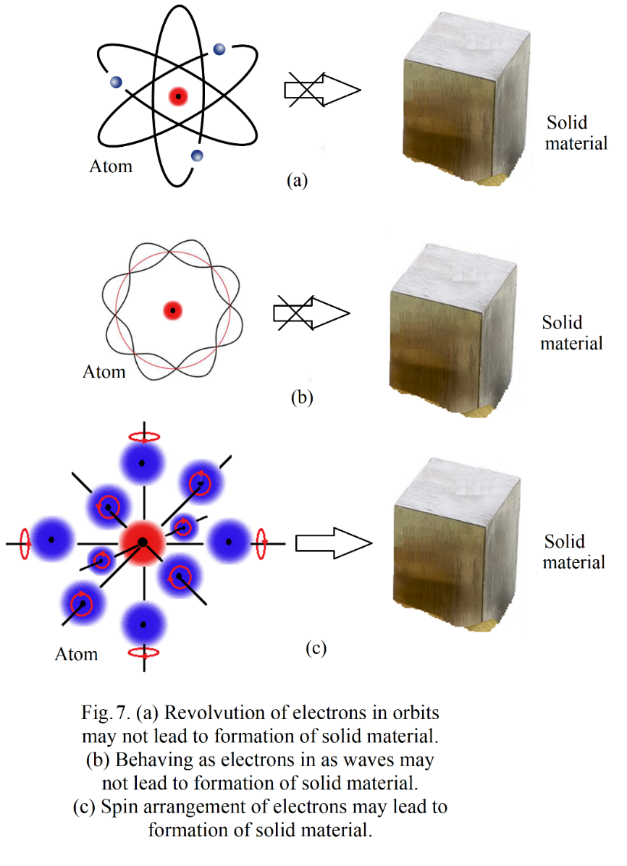

Further, it is found that, a sodium atom emits a light wave consisting 650 wavelengths approximately. It implies that the corresponding electron in the atom should oscillate 650 times while producing the light wave with frequency of the wave. Further it should oscillate at particular and fixed position in the atom. Consequently the electron should not be revolved or acted as a wave in the atom.

**Conclusion:**

Electrons in atoms may not be circulating in stationary orbits about the nucleus as proposed by Bohr or may not be behaving as waves as proposed by Schrodinger. They can maintain their safe distance from the nucleus by adjusting their spin motions. Spin is not an intrinsic property of electrons. It is acquired by them through the need of distribution in atoms. Ability of electrons to keep safe distance from nucleus by adjusting their spin motions in atoms without revolving around the nucleus makes possible the atoms to form molecules, compounds and solid materials.

**Reference:**

1. G. H. Jadhav, ‘On Atomic Structure’, Submitted to IJSRPAS on 31st Oct 2021 with Paper ID-ISROSET- IJSRPAS-P-06836.

---------------------------------------------